TIP OF THE WEEK – HELPING NECK AND SHOULDER STRAIN
Are your shoulder and neck feeling the strain?  Run through this checklist for suggestions. | 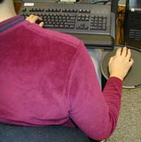
Are the spacebar of your keyboard and your monitor centered in front of you?  Suggestion: Center the spacebar of the keyboard in front of you.  Why?  • Helps place your body in a neutral position. | 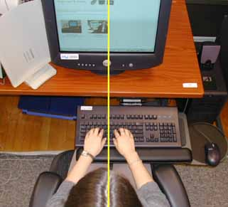
Is your keyboard positioned so that your forearms are parallel with your thighs at or below horizontal, while your feet are flat on the floor?  Suggestion: Position the keyboard so that your forearms are parallel to your thighs when your feet are flat on the floor.  Why?  • Helps maintain blood flow in the hands and arms.  • Decreases muscle strain and tension. | 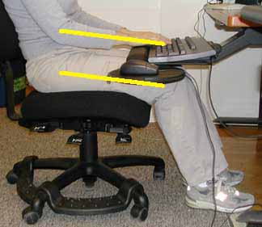
Do you keep your elbow close to your body and allow your arm to be relaxed while using the mouse?  Suggestion: Keep your elbow close to your body and allow your arm to relax while you use the mouse.  Why?  • Places the arms in a neutral and relaxed position.  • Prevents overreaching and twisting of the shoulder, arm and wrist. | 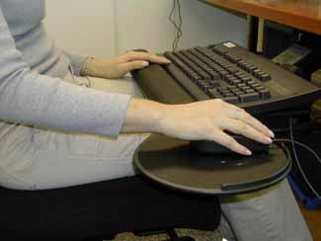
Is your chair too close or too far away from the keyboard, causing your arms to be outstretched and/or your neck and shoulders to strain?  Suggestion: Adjust the height of your chair to use the keyboard and mouse properly (see keyboard and mouse sections after finishing chair tips). After making this height adjustment your feet cannot be placed flat on the floor, use a foot rest.  Why?  • Encourages good posture.  • Enables proper sitting height.  • Avoids pressure placed on the back of the thigh.  • Promotes circulation. | 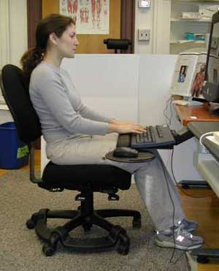  Department of Design and Environmental Analysis, College of Human Ecology,  Cornell University.

